

SANDHURST ADVISORY SDN BHD

EECA Compliance Readiness
Preliminary Assessment Report
A self-assessment evaluation of compliance readiness positioning under the Energy Efficiency and Conservation Act 2024.
Prepared For | [Client Company Name]
Respondent | [Respondent Name], [Designation]
Facility / Plant | [Facility Name]
Prepared By | Sandhurst Advisory
Date of Report | [Date]
Reference No. | EECA-SA-[AutoID]


Powered by:

1. Executive Summary
This Preliminary Assessment Report provides a high-level overview of your facility's current readiness position concerning the upcoming requirements of the Energy Efficiency and Conservation Act (EECA). The analysis is derived from the self-reported parameters provided during the EECA Compliance & Readiness Checklist assessment.

Overall EECA Readiness Status
Severe Gap (0-39) | Low (40-59) | Moderate (60-79) | Ready (80-100)
Score: 65 / 100
MODERATE READINESS

Overall Summary: [Your facility demonstrates a baseline understanding of the EECA requirements with certain elements already initiated. However, critical structural gaps remain in formal data readiness, systemic Energy Management System (EnMS) deployment, and definitive audit signoffs.]

2. Response Summary & Gap Analysis
Assessment Category | Current Status / Input
Facility Type | [Industrial / Commercial]
Likely EECA Applicability | [Applicable / Not Sure / Exempt]
12-Month Energy Data Readiness | [Complete / Partial / Missing]
REM Appointment Status | [Appointed / In Progress / None]
EnMS Status | [Implemented / Partial / None]
EnMS Elements in Place | List of Selected Elements
EnMS Activities in Place | List of Selected Elements
EE&C Report Readiness | [Ready / Gaps Exist / Not Ready]
Energy Audit Readiness | [Completed / Pending REA / None]
EIL Readiness (If applicable) | [Ready / Partial / Not Ready]
Major Gaps Identified (Severe Risk):
- A Registered Energy Manager (REM) has not yet been formally appointed.
- Energy audit readiness is incomplete and requires a Registered Energy Auditor (REA) full scope review.
Moderate Gaps Identified:
- The Energy Management System (EnMS) is not yet fully established across all required levels.

3. Indicative EECA Compliance Timeline
Understanding the statutory deadlines is critical. The following timeline illustrates the standard compliance milestones required once a facility is officially notified by the Energy Commission.
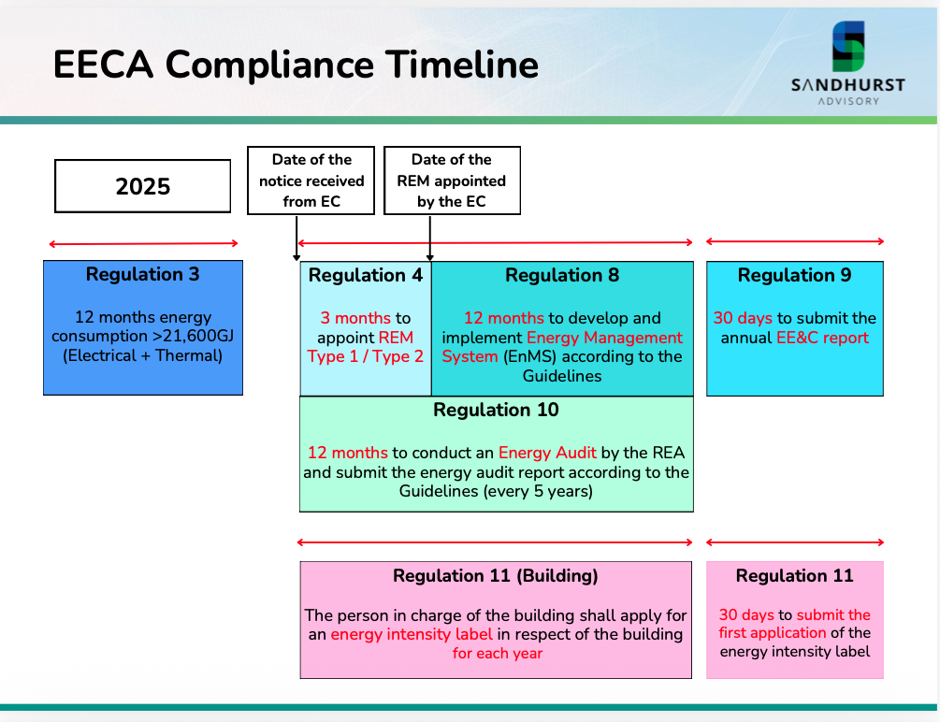

4. Recommendation of Implementation Actions
To bridge the compliance gaps identified in your self-assessment, the following framework categorizes the mandatory EECA requirements. Your facility's engineering and management teams may utilize this structured workspace to outline specific, assignable action plans.
EECA Category | Identified Gap / Status | Recommended Action Plan | Target Date / Owner
A. REM Appointment | [Auto-filled] e.g., No formal REM appointed.
B. EnMS Establishment | [Auto-filled] e.g., Partial policies.
C. EE&C Reporting | [Auto-filled] e.g., Data not finalized.
D. Energy Audit (REA) | [Auto-filled] e.g., Pending REA sign-off.

5. Summary of Key EECA Requirements

The following is a structured breakdown of the critical statutory requirements under the EECA relevant to energy consumers and applicable buildings, categorized for ease of understanding.

A. Applicability & General Scope

Applicability under the EECA must first be determined by the Energy Commission based on the Act and the relevant guidelines.

The Act applies to qualifying energy consumers, applicable buildings, and specified energy-using products.

For energy consumers, applicability is generally based on total energy consumption over 12 consecutive months.

The current energy consumer threshold in the guideline is 21,600 GJ over 12 consecutive months.

The Energy Commission may issue a written notice once it ascertains that a person is an energy consumer to whom the Act applies.

The Energy Commission may also issue a written notice once it ascertains that a building is a building to which the Act applies.

B. Registered Energy Manager (REM)

An applicable energy consumer is required to appoint a properly registered REM holding a valid practicing certificate.

Type I REM: Certified to manage, advise, and report specifically on Electrical Energy efficiency and consumption.

Type II REM: Certified to manage, advise, and report on BOTH Electrical and Thermal Energy. A Type II REM must be engaged if the total yearly energy consumption is more than 50,000 GJ.

External REM Engagement: Facilities may opt to engage an external REM, but the engagement period is strictly limited to a maximum of 3 years.

C. Energy Management System (EnMS)

An applicable energy consumer must systematically develop and integrate an EnMS into their daily operations. The EECA aligns closely with the continuous improvement framework (such as ISO 50001), strictly requiring:

Management Commitment & Policy: Top management must formally endorse a customized Energy Policy, appoint a dedicated energy committee, and allocate adequate financial/human resources.

Energy Planning & Baselines: Identifying Significant Energy Uses (SEUs), establishing a valid 12-month energy consumption baseline, and setting quantifiable Energy Performance Indicators (EnPIs) and reduction targets.

Implementation & Operation: Integrating energy efficiency criteria into procurement processes, establishing Standard Operating Procedures (SOPs) for high-consumption equipment, and ensuring facility-wide awareness training.

Measurement & Verification (M&V): Deployment of continuous, real-time, or highl structured periodic monitoring of energy consumption to track progress against set targets.

Review & Internal Audits: Conducting periodic internal audits and formal management reviews to evaluate performance, address gaps, and drive continual energy improvement.

D. Reporting & Energy Audits

Energy consumers are strictly required to compile and submit the Energy Efficiency and Conservation (EE&C) Report within the mandated timeline:

Frequency: The first EE&C Report must be submitted to the Energy Commission within 12 months from the date of the written notification. Subsequent reports must be filed annually.

Main Reporting Areas:

General facility description, organizational profiling, and production metrics.

Total energy consumption profile broken down by energy source (electricity, thermal, natural gas, etc.).

Detailed status of the EnMS implementation, energy policy updates, and progress of the energy committee.

Status and outcomes of energy efficiency and conservation measures (EECMs) executed during the period.

E. Energy Audit Requirements

An energy consumer is required to carry out mandatory energy audits periodically:

Frequency & Timing: The first energy audit must be conducted and submitted within 1 year of the date of applicability/notification. Subsequent audits are required at least once every 4 years.

Audit Execution: The audit must be conducted by a Registered Energy Auditor (REA) holding a valid practicing certificate.

Audit Reporting: The audit findings must be systematically organized into an Energy Audit Report, containing energy efficiency findings, operational recommendations, and financial/ ROI feasibility analyses, and must be signed off by the REA before submission to the Commission.

F. Energy Intensity Labeling (EIL)

Applicable office buildings must compute and display their Energy Intensity Label (EIL) rating:

Parameters for Rating Calculation: The Energy Intensity Performance (EIP) of the building is calculated as the Building Energy Intensity (BEI) in kWh/m2/year, taking into account:

Total annual energy consumption of the building (all sources converted to equivalent kWh).

Gross Floor Area (GFA) of the building in square meters (excluding non-conditioned spaces as defined by the guidelines).

Operating hours and climate/occupancy adjustment variables where applicable.

When to Apply: The building manager must apply for the EIL rating within 12 months of the date of applicability/notification and must systematically renew the label after each prescribed reporting cycle.

6. Partnering with Sandhurst Advisory
Achieving compliance under the Energy Efficiency and Conservation Act (EECA) can be complex, but you do not have to navigate it alone. Sandhurst Advisory is ready to support your organization through every step of your EECA compliance journey.
We offer a comprehensive suite of professional energy management services tailored to your operational scale, including:
- Compliance Advisory: Strategic consulting to clarify applicability and legal requirements.

- Comprehensive Energy Audits: Full-scope assessments conducted by Registered Energy Auditors (REAs).

- EnMS Training & Establishment: Policy design, target setting, and full implementation of Energy Management Systems compliant with regulatory guidelines.

- Real-Time Monitoring Services: Advanced data aggregation and IoT telemetry to effortlessly capture your 12-month energy baselines and continuous performance.
Contact Sandhurst Advisory today to ensure seamless compliance, mitigate regulatory risks, and optimize your facility's long-term energy performance.

Disclaimer: This report is based solely on the information provided through the EECA Compliance & Readiness Self-Check tool. It is intended as a preliminary advisory document only and does not constitute legal confirmation of compliance status, formal regulatory determination, or professional certification under the Energy Efficiency and Conservation Act 2024. Sandhurst Advisory takes no liability for this report as it is an auto-generated self-assessment. User discretion is strictly required, and formal consultation is recommended for definitive compliance mapping.

